Enterprise Office Network Design & Implementation
Cisco Packet Tracer Project
1 Project Overview
Designed and implemented an enterprise office network using Cisco Packet Tracer to simulate a real-world corporate network environment. The project focuses on connecting multiple departments, organizing network infrastructure, configuring essential network services, and performing connectivity testing and troubleshooting.
2 Network Infrastructure
Configured a Cisco 2911 router.
Designed a centralized network architecture using a Core Switch.
Connected departmental switches for Administration, Human Resources, Finance, and IT.
Integrated servers, a network printer, and a wireless access point.
Configured network connections and verified interface connectivity.
3 VLAN Configuration
Created six Virtual LANs (VLANs) to logically separate departments and organize network traffic.
VLAN ID Department Network Address
10 Administration 192.168.10.0/24
20 Human Resources 192.168.20.0/24
30 Finance 192.168.30.0/24
40 Information Technology 192.168.40.0/24
50 Servers 192.168.50.0/24
60 Wireless Network 192.168.60.0/24

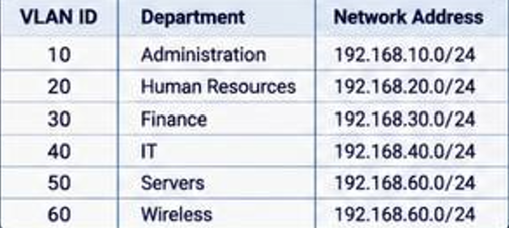

4. Network Services and Configuration
DHCP (Dynamic Host Configuration Protocol): Configured DHCP pools to automatically assign IP addresses to departmental devices.
Inter-VLAN Routing: Implemented Router-on-a-Stick using router subinterfaces to enable communication between different VLANs.
Trunking: Configured trunk links to carry traffic from multiple VLANs between network devices.
DNS (Domain Name System): Enabled DNS service on the SRV-DATA server and created an A record mapping app.company.local to 192.168.50.10.
5 Server Configuration
Device IP Address Function
SRV-APP 192.168.50.10 Application Server
SRV-DATA 192.168.50.11 DNS Server
PRN-MAIN 192.168.50.12 Network Printer
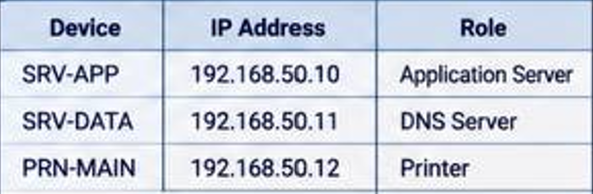
6 Connectivity Testing and Verification
Performed connectivity tests using the Ping command.
Verified communication between network devices and different subnets.
Tested access to servers using IP addresses and domain names.
Verified successful DNS name resolution for app.company.local, resolving to 192.168.50.10.
Achieved 0% packet loss in the final connectivity test.
7 Network Troubleshooting
Practiced identifying and troubleshooting common network issues, including:
Physical connectivity and disconnected cables.
Administratively disabled switch ports.
Incorrect VLAN assignments.
Native VLAN mismatch.
Err-disabled ports associated with BPDU Guard.
Understanding CRC errors, input errors, and oversized frames (Giants).
DNS configuration and name resolution testing.
8. Tools and Technologies
Cisco Packet Tracer
Cisco IOS Command-Line Interface (CLI)
VLANs and Trunking
DHCP and DNS
Router-on-a-Stick
IPv4 Addressing and Subnetting
Ping and Network Troubleshooting

9 Skills Developed
Enterprise LAN Design and Implementation
Router and Switch Configuration
VLAN Management and Network Segmentation
IP Addressing and Subnetting
Network Services Configuration
Connectivity Testing and Troubleshooting
Network Documentation

